Integrity Constraints

* Integrity constraints are a set of rules. It is used to maintain the quality of information.
* Integrity constraints ensure that the data insertion, updating, and other processes have to be performed in such a way that data integrity is not affected.
* Thus, integrity constraint is used to guard against accidental damage to the database.

## Types of Integrity Constraint

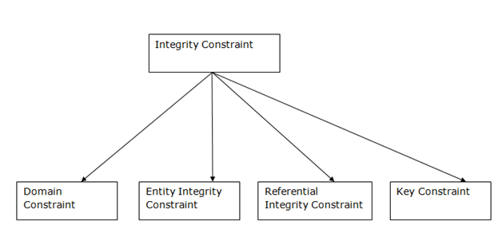

### 1. Domain constraints

* Domain constraints can be defined as the definition of a valid set of values for an attribute.
* The data type of domain includes string, character, integer, time, date, currency, etc. The value of the attribute must be available in the corresponding domain.

**Example:**

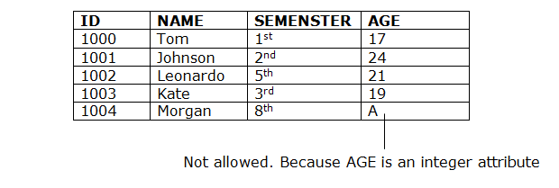

### 2. Entity integrity constraints

* The entity integrity constraint states that primary key value can't be null.
* This is because the primary key value is used to identify individual rows in relation and if the primary key has a null value, then we can't identify those rows.
* A table can contain a null value other than the primary key field.

**Example:**

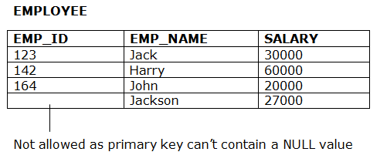

### 3. Referential Integrity Constraints

* A referential integrity constraint is specified between two tables.
* In the Referential integrity constraints, if a foreign key in Table 1 refers to the Primary Key of Table 2, then every value of the Foreign Key in Table 1 must be null or be available in Table 2.

**Example:**

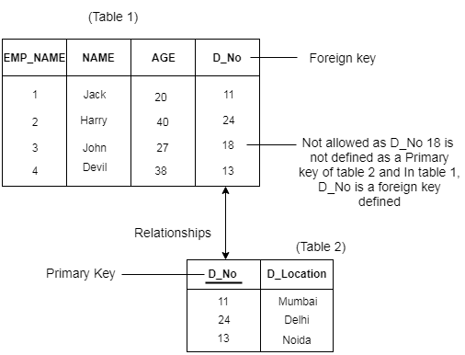

### 4. Key constraints

* Keys are the entity set that is used to identify an entity within its entity set uniquely.
* An entity set can have multiple keys, but out of which one key will be the primary key. A primary key can contain a unique and null value in the relational table.

**Example:**

